HB-PPT |  | LSZF: 056 464 40 40 | Flugplan: 0800 437 837 | ETA_{max} | 11:30 | ÖL, PI, Pz
P28A | Zähler |  | Ausland: +41 43 931 61 61 | ETE | 02:00
4
2
6
8
10
14
12
16
20
18
22
24
26
30
28
QNH |  |  |  |  | ALTERNATE FRQ/runway/altitude/Outbound/Zoll  Locarno LSZL | ATIS 133.455 | TWR 134.825  GND 121.7 | DW 2000 | ELEV 650 | 600 m | 08L–26R | Zoll: OPR hours.
SQUAWK
RW |  |  | INFO |  | Departure FRQ/runway/altitude/Outbound/Zoll  Friedrichshafen EDNY | ATIS: 129.605  TWR: 120.080 | 06-24 | ELEV 1368 Fuss 2350 m | Zoll: immer verfügbar.
Fuel _{t/l}  45l/h | 02:00  01:30  03:30 |  | ______ | ______
Info # EM: 134.130 | BA: 134.675 ° 130.9 | GE: 126.350
Twr # EM: 120.425 | BU: 119.625 | ME: 130.150
Atis # ZH: 129.005 | AD # BI: 123.555

 |  | Waypoints |  |  | MT | EET | ETO | ATO | V_{x} |  | 64 |  |  | V_{y} | 76 | V_{a} |  | 113 | V_{bg} | 76 | V_{gs} 64
 |  | Friedrichshafen |  | EDNY |  |  | DEP» 09:20 |  | X GPS |  |  |  | IMPORTANT / FRQ / ALTITUDE
 |  | Outbound W |  |  | VAC | 5 | 25 |  |  | FP 0900 |  |  |  |  |  |  | Max 3000 Fuss
 |  | Kreuzlingen |  |  | 255 | 6 |  |  | 4500 | Züri Info: 124.7 | Autobahn
 |  | Frauenfeld |  |  | 245 | 8 |  |  | Zurich TWR: 118.1
 |  | E | Zürich (CTR ZH) |  |  | 250 | 3 |  |  | Max 3500
 |  | E1–E2–(28)–W2–W1–S |  |  | VAC | 12 |  |  | Max 3000
 |  | Unterägeri |  |  | 180 | 8 |  |  | 4000
 |  | Flüelen |  |  | 178 | 9 |  |  | | Max FL 90 | Ab Brunnen: Max FL 130
 |  | Gotthard Pass |  |  | 190 | 10 |  |  | Mind. 8200
 |  | San Giacomo |  |  | 216 | 4 |  |  | Milano Info: 124.925
 |  | Pieve Vergonte |  |  | 195 | 14 |  |  | Max. 2600 -> LIR83E (danach 3000)
 |  | Varese |  |  | 112 | 13 |  |  | 3000-5500 (LIP 265) N Bahnlinie | Descent Check
 |  | Stabio |  |  | 067 | 3
 |  | CAPOLAGO |  |  | 035 | 2
 |  | E |  |  | 346 | 3 |  |  | 3000
 |  |  |  |  |  |  |  |  | FP
 |  | Lugano |  | LSZA | VAC | 5 |  |  | V_{f}: 65 | C_{w}: 17
Destination _{FRQ/runway/altitude/Outb./Zoll}  Lugano | LSZA | ATIS: 121.175  Lugano TWR: 120.250  DW: 2600 Fuss  01-19 | ELEV 915 Fuss  1100 m  Zoll: immer verfügbar. | Startup Departure Info TMA Cr. CTR Cr. Arrival  HB- HB- HB- HB- HB- HB-  Position Holding p./b. P28A P28A P28A VFR from  VFR to Outbound VFR from/to VFR from | to Position Position  Information Req. turn right Position Position Request Info  Outbound Ready for dep Routing POB Via  Request T. POB | EET Dep. Time + FP request For Landing

1 | Line Up |  | door, Windows, Landing Light, Strobe Light, Time / GPS, Approach sector & runway || RPM 2400
2 | Climb |  | Flaps, Throttle, Fuel pump, landing light, Flarm
3 | Cruise |  | Altimeter, Gyro, Power, Fuel Left | Fuel Right | Endurance | Fuel selector, Mixure
4 | Descent |  | ATIS, Approach briefing, Avionics, Gyro, Cabin and Pax
5 | Approach |  | Altimeter, Landing light, Fuel: L|R | E, pump, Fuel selector, Mixture, Carburetor heat ↓, Autopilot
6 | Power setting |  | Downwind: 2000 RPM (85 Knoten) || Point of descent: 1200 RPM
7 | Final |  | Flaps, Mixture, Carburator heat ↑
8 | After landing |  | Transponder, Strobe light, Fuel pump, Flaps
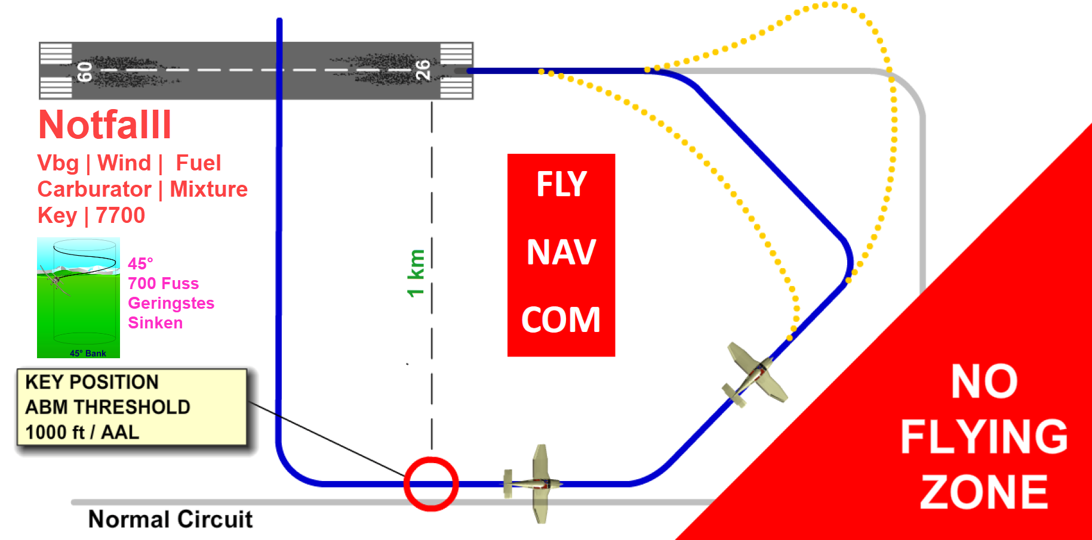

NR | E
 | X | Flugbuch, Lizenz, Medical, ID
 | X | Kopfhörer - Batterien geladen
 | X | Tablet für Navigation (Hauptgerät), geladen, Passwort | Kniegürtel
 | X | Tablet für Navigation (Reserve), geladen, Passwort
 | X | Zusatzbatterie, Ladegerät, Kabeln, Ersatzkabeln, Adapter, Verteiler
 | X | Laptop, Mouse, USB-Stick | Notizbuch | Multifach-Mappe | Minitasche
 |  | Start | Navigationsplan
 | X | NOTAM: Flugplätze
 | X | Öffnungszeiten: ATC, Flugplatz, Fuel (AVGAS) | Kosten: Flugplatz, Fuel |  Parking – Verfügbarkeit | Pilot Notes
 | X | Zoll (Departure und Arrival) - Zeiten und Bedingungen beachten
 | X | Weight & Balance, Startrollstrecke, Startleistung (über Hindernisse)
 | X | SD: METAR, TAF, GAFOR, Wind, Rain | Windy: Sicht, Niederschläge, Wind: Piste
 | X | Route: Topografie, Luftraum, Bestimmungen, Notam oder DABS (Optimale Höhe, min. or max. Höhe, alternative Routen wegen Wetter oder ATC)
 | X | WP Descent Check | Approach Check
 | X | Point of descent (500 F = 1 nm) | Landeprozedur
 | X | Frequenzen: Info, ATC
 | X | Sprüche für ATC
 | X | Route in der Cloud (für Tablet, mit aktuellen VAC- und Transitkarten)
 | X | SkyDemon-Karte auf Papier oder ICAO-Karte
 | X | Karten auf Papier (Departure, Destination, Alternate. Transit-Karten) | Bostitch
 | X | Leere Navigationspläne (als Reserve)
 | X | 2 gespitzte Bleistifte
 | X | Flugzeug: Nächster Service | Flugzeugdaten: MTOW:1157kg, Noise: D
 | X | Flugplan: Verteileradressen: LSZFZTZX | Ausrüstung: DGOY S | EET/XXX0008
 | X | Roaming, Internet im Ausland
 | X | Gelbe Weste (High-visibility safety clothing)
X |  | Schwimmweste
 | X | Essen, Trinken
 | X | Geld (CHF, Euro, Kreditkarten) | Hotel | Taxi
 | X | Gesundheit | Sonnenbrille, Sonnencreme, Lippe, Hut
 | X | Navigationsplan auf Papier (rechtes Knie)
 | X | YJ = Yellow Jacket | HP = Headphone | C = Custom | Pl = Pillow  S = Schwimmweste | Öl | Pz = Putzmittel (Wasser, Papier)

